# Data Browser Overview

The Data Browser provides the IT Administrator role a view of data in inBloom that is relevant to their Education Organization. This information can be used to instill confidence that the data stored is an accurate reflection of what has been loaded as well as provide the detail that is needed to troubleshoot discrepancies in data. In addition, it aids the IT Administrator solve the following use cases:

**Use Cases:**

An IT Admin, I want to view counts, so that I can I can understand the amount of data I have within my EdOrg.

Example 1: I am loading data into my EdOrg, I want to make sure the correct number of records loaded.

As an IT Admin, I need to understand discrepancies in data between my EdOrg’s data and what the actual data should be, so I can respond to inquiries regarding counts and/or discrepancies.

Example 2:

There are 100 schools in my district, however my EdOrg is only showing 95 schools, I need to identify which schools are missing.

A teacher’s roster is wrong, I need to search for the specific teacher and view the detail of the class roster, so that I can identify the incorrect data.

As an IT Admin, I want to understand the status of previous ingestion jobs, so that I can determine the overall health of my ingestions and use this information in troubleshooting data discrepancies.

Example 3:

I just completed an ingestion job, and I want to understand whether it was successful and the number of records that were actually ingested, compared to what I sent in the file.

**Data Browser Homepage:**

The Data Browser homepage provides a data overview and information on previously completed Ingestion Jobs. All navigation is through the Education Organization on the homepage.

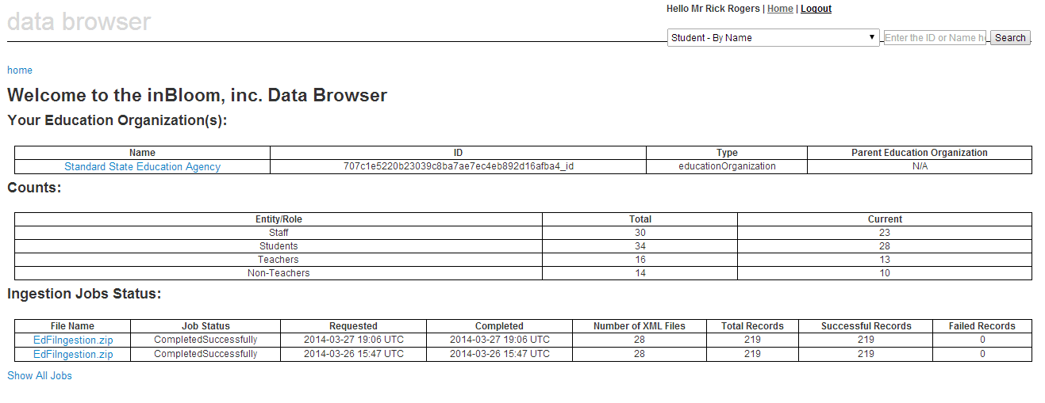

**Counts:**

Counts of entities are displayed throughout the Data Browser. When applicable, both the total and current number of entities are listed.

## Navigating the Data Browser:

When you click on the Education Organization off the home page, you are taken to an Education Organization page, with attributes about the Education Organization, counts for the Education Organization, and links for each entity associated to it with their counts. Clicking on each entity link allows the IT Administrator to navigate through the Data Browser and their data.

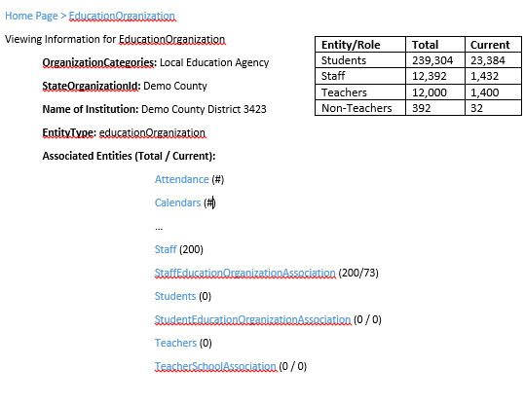

# Ingestion Information

**Completed Ingestion Jobs Status**

On the Data Browser homepage, the Completed Ingestion Jobs Status table provides information on the latest 5 Ingestion Jobs that completed for your Tenant. If you have more than one person in your tenant that submits ingestion jobs, they will all be present in this table for all IT Admins. This information is not filtered based on Education Organization.